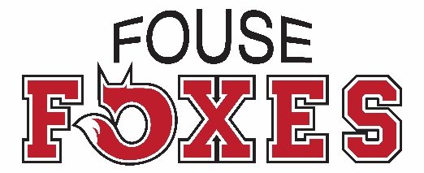
Pancake Breakfast Drawing Contest

Calling All Foxes: Let’s see your artwork!
Please draw a picture that you think best represents Fouse’s Pancake Breakfast and/or the Fall season. The winning drawing(s) will be featured on this year’s Pancake Breakfast flier. Note: It’s best to keep your drawing’s background simple. Artwork with a light background will appear most clearly on Pancake Breakfast Flier.
Entries Due: Friday, Oct. 5th ● Winners Announced: Thursday, Oct. 11th
Student Name: ___________________________ Grade: ____ Teacher:______________

● 9th Annual Fouse Family Pancake Breakfast ●
Save the Date: Saturday, November 10, 2018 ● Fouse Elementary School ● 8:30am – 11am
Gather your friends & family for an all-you-can-eat buffet of pancakes, sausage, coffee, milk & juice!
Further details coming soon!

